Practical 7
Problem Definition
Process submitted registration/contact form data using PHP. Validate and sanitize inputs on the server side and store records in CSV or JSON file format. Display success/error messages.
Index.php:-
<?php
$name = $email = $message = "";
$success = "";
$error = "";

if ($_SERVER["REQUEST_METHOD"] == "POST") {

// Sanitize input
$name = trim($_POST["name"] ?? "");
$email = trim($_POST["email"] ?? "");
$message = trim($_POST["message"] ?? "");

$name = htmlspecialchars($name, ENT_QUOTES, "UTF-8");
$message = htmlspecialchars($message, ENT_QUOTES, "UTF-8");
if (empty($name) || empty($email) || empty($message)) {
$error = "All fields are required.";
} elseif (!filter_var($email, FILTER_VALIDATE_EMAIL)) {
$error = "Please enter a valid email address.";
} else {
$file = fopen("records.csv", "a");

if ($file !== false) {
fputcsv($file, [$name, $email, $message, date("Y-m-d H:i:s")]);
fclose($file);

$success = "Registration submitted successfully!";

$name = $email = $message = "";
} else {
$error = "Unable to save the record.";
}
}
}
?>

<!DOCTYPE html>
<html>
<head>
<title>PHP Form Processing</title>
<style>
body {
font-family: Arial, sans-serif;
background: #f2f2f2;
padding: 30px;
}

.container {
width: 350px;
margin: auto;
background: white;
padding: 20px;
border-radius: 10px;
}

input, textarea, button {
width: 100%;
padding: 10px;
margin: 8px 0;
box-sizing: border-box;
}

button {
background: green;
color: white;
border: none;
cursor: pointer;
}

.success { color: green; }
.error { color: red; }
</style>
</head>
<body>

<div class="container">
<h2>Registration Form</h2>

<?php if ($success != ""): ?>
<p class="success">
<?= htmlspecialchars($success) ?>
</p>
<?php endif; ?>

<?php if ($error != ""): ?>
<p class="error">
<?= htmlspecialchars($error) ?>
</p>
<?php endif; ?>

<form method="POST" action="">
<label>Name:</label>
<input type="text" name="name"
value="<?= htmlspecialchars($name) ?>"
required>

<label>Email:</label>
<input type="text" name="email"
value="<?= htmlspecialchars($email) ?>"
required>

<label>Message:</label>
<textarea name="message" required><?= htmlspecialchars($message) ?></textarea>

<button type="submit">Submit</button>
</form>
</div>

</body>
</html>
Screenshot:-
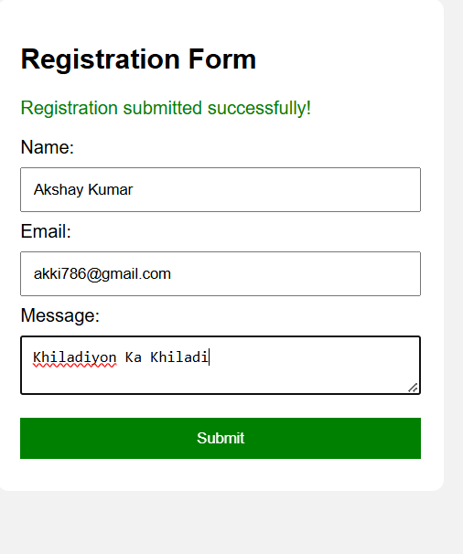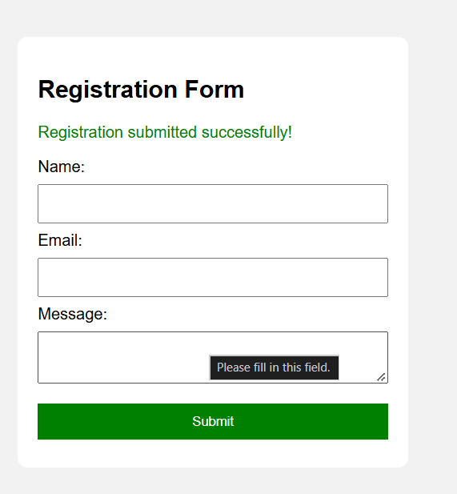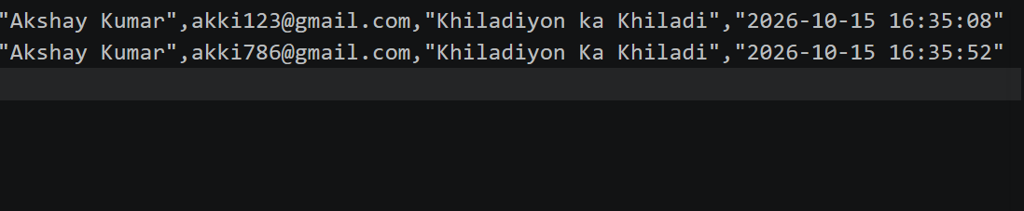
Records.csv:-
"Akshay Kumar",akki123@gmail.com,"Khiladiyon ka Khiladi","2026-10-15 16:35:08"
"Akshay Kumar",akki786@gmail.com,"Khiladiyon Ka Khiladi","2026-10-15 16:35:52"
Key Questions :-
1. Is the form submitted using POST?
Yes. The form uses method="POST" to send data to the PHP server. The $_SERVER["REQUEST_METHOD"] checks whether the form was submitted using POST.
2. Are inputs validated and sanitized server side?
Yes. The trim() function removes extra spaces, filter_var() validates the email address, and htmlspecialchars() escapes special characters when displaying user input. Empty fields are also checked.
3. Is file writing handled safely?
Yes. The fopen() function opens the CSV file in append mode ("a"), and fputcsv() stores the data in CSV format. The code checks whether the file opened successfully and closes it using fclose().
4. Are success and error responses displayed clearly?
Yes. A green success message appears when data is saved successfully. Red error messages appear when fields are empty, the email is invalid, or the file cannot be opened.

